FNCE 2404 Final Project

Group 2

Shikha Binani, Katherine Prieto, Kaitlyn Kissner

**Time Series Analysis of**

**Online Travel Tech Industry**

**Stock Prices**

**Introduction**

Over the course of the past year and a half when the world shut down and everyone was confined to their homes, companies that were focused on the travel industry faced many losses. With the widespread availability of vaccines and the general lessening of Covid-19 restrictions, we will be exploring closing stock price time series data for three large companies in the online travel tech industry: Airbnb, Expedia, and Booking Holdings. We will be looking into the forecast of future stock prices for this industry in order to analyze the data and help investors understand whether it is a good idea to invest now considering our economy and the industry may be gradually recovering from the impact of Covid-19. Our forecasts will be tailored to the investor who is curious about the online travel tech industry but is unsure on whether it would be a good investing opportunity.

All of the data that we will be presenting here comes from the Yahoo! Finance site. Through this site we were able to access all of the opening, high, low, and closing stock prices for each day that the market was open since the original IPO dates of the companies. In our case, we will just be paying attention to the closing prices in order to see the overall trends over time and forecast future closing prices.

We did not have any challenges when looking for the data that we needed to forecast. All of the stock prices for each day is public information that is fairly easy to find, so we could easily access this data on all three of the companies going all the way back to 1999 for Booking and 2005 for Expedia. In this case, we will be looking at the past five years of data. For AirBnb, their IPO took place on December 9th, 2020, so this is the earliest date that any data on stock prices is available. This was a bit of a challenge in terms of the big picture of our forecast because we are not able to look back nearly as far as we will be able to Booking and Expedia. The focus of our analysis will be on how Covid has affected this industry, so we will not have any pre-Covid data here to compare. In this case, we will just be looking at whether or not this is a good investment given the more recent decline in Covid regulations.

**Industry Background**

The COVID-19 pandemic hit the tourism industry hard in 2020, as governments implemented travel bans and stay-at-home measures in order to contain the spread of the virus. This of course had an impact on the online travel tech sector as well. The year-over-year change in short term rental bookings through leading online travel agencies worldwide during the [pandemic](https://www.statista.com/page/covid-19-coronavirus) showed a large reduction in bookings. By week 35 of the pandemic, Booking and Airbnb still reported over sixty percent less rental bookings, while Expedia reported over 80 percent less. Booking Holdings recorded a global operating loss of roughly $631 million in 2020. In 2019, the company's operating income amounted to about $5.35 billion. Expedia Group, Inc. recorded an operating loss of roughly $2.7 billion in 2020. In 2019, the company generated approximately $903 million of operating income.

According to Statista, in 2020, the market size of the global tourism sector declined over the previous year, reaching $1.09 trillion whereas the industry's market size was forecast to rise to $1.3 trillion in 2021. However, after dropping by over $400 million since 2019 the global travel and tourism market began to recover and generated revenue in excess of $380 million, an increase of around 100 million since 2020. Estimates of the Statista Mobility Market Outlook say that by 2022 the revenue will reach over $600 million and by 2023 will return to a pre pandemic amount of over $730 million.

**Data Examination**

To begin our analysis on 3 major travel tech companies, Airbnb, Expedia, and Booking Holdings we plot closing prices across a 5-year time span starting from January 1, 2016, to the current day.

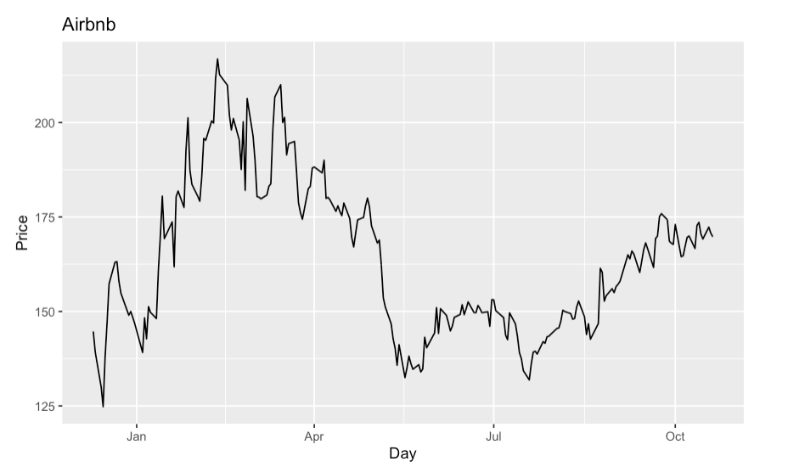

In our Airbnb plot analysis, we can see both upwards and downwards trend across time from January 1, 2016, up until today. We can see an inclining upwards trend from January 1, 2016, to February 11, 2021. On February 11, 2021, we see the maximum closing price for Airbnb in a 5-year span at $216.84 per share. Soon after Airbnb’s closing price we see a decline in trend reaching the lowest closing price at $214.80 on December 15, 2020. As well as identifying trends in our Airbnb plot, we can see seasonality because there is some sort of an identifiable pattern cycling through every year.

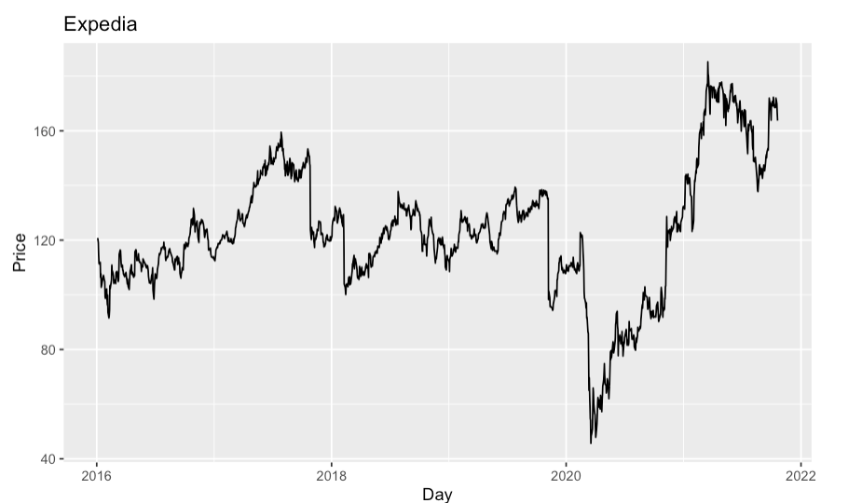

In our analysis for Expedia, we can make similar remarks about trends as we did for Airbnb. Although the magnitude of the upwards and downwards trend is less distinct, we can see climbing closing price values for Expedia from January 1, 2016, to November 1, 2017. Then we see a downwards trend soon after. The lowest closing price value we see for Expedia occurred on March 18, 2020, at a closing value of $45.65 per share. The highest closing price value for Expedia occurred on March 17, 2017, at a closing value of $185.27. As well as being able to identify distinct trends, our model includes a seasonality factor as we can identify patterns in certain clusters of months each year.

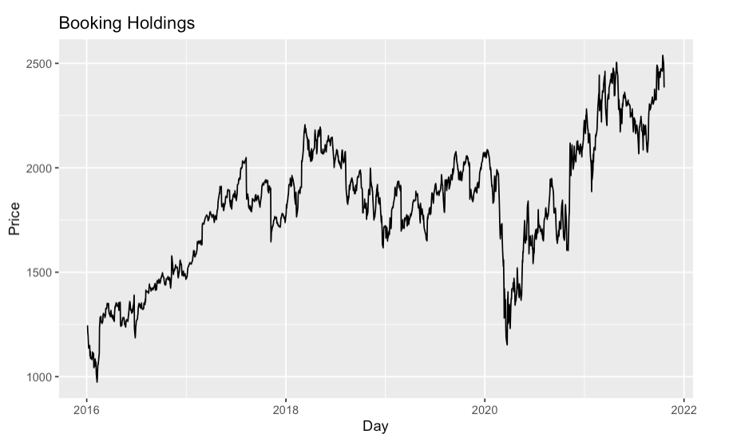

In our analysis for Booking Holdings, we can see upwards and downwards trends across time. From January 1, 2016, to January 1, 2018, we can see an upwards trend of climbing closing price values. In the early months of 2020, we can see significant downwards trends in closing price value, and soon after we see a gradual positive incline. The lowest closing price value we see for Booking Holdings occurred on February 8, 2016, at a closing value of $973.8 per share. The highest closing price value for Booking Holdings occurred on October 10, 2021, at a closing value of $2538.34. Similar to Expedia, our model includes a seasonality factor as we can identify patterns in certain clusters of months each year.

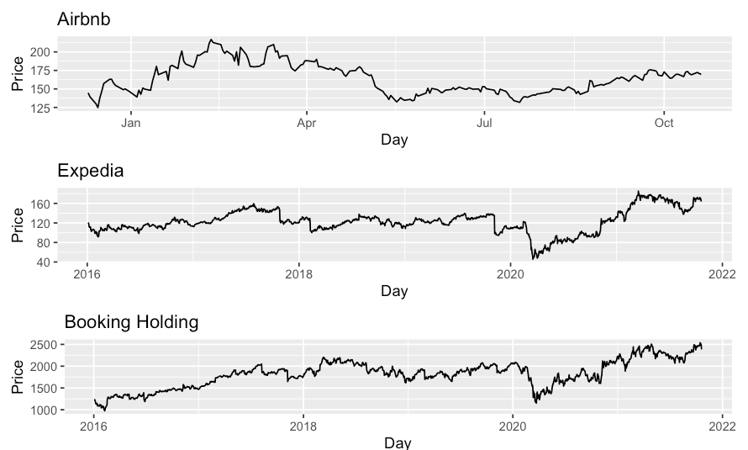

**ARIMA Model**

In all our three-time plots of Airbnb, Expedia, and Booking Holdings we have been able to identify trends as well as seasonality. Given that all three-time plots are non-stationary, in this section we will build upon the model using the Autoregressive Integrated Moving Average Model to forecast future pricing for these three companies. In order to do so, a common rule of thumb is to perform transformations that will allow us to control for trend and seasonality in our model. We begin by performing a log transformation on each dataset to control for variances and scale down the unit values. Below, I include all three-time plots of the logged values of Airbnb, Expedia, and Booking Holdings.

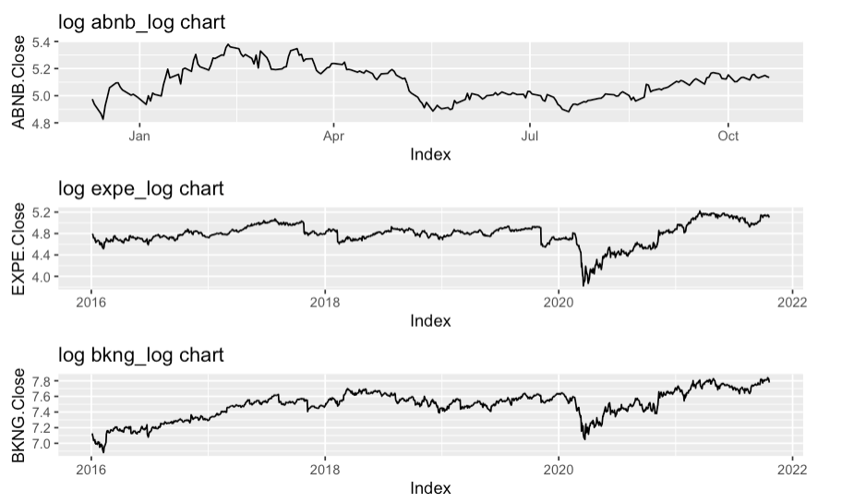

In the plot above we can see a more condensed time plot, where variability is controlled. Now that we have controlled for variability in our model, we conduct one more transformation to mitigate seasonality amongst all three models. In the plot below, we plot Airbnb, Expedia, and Booking Holdings across time at a lagged value of 1.

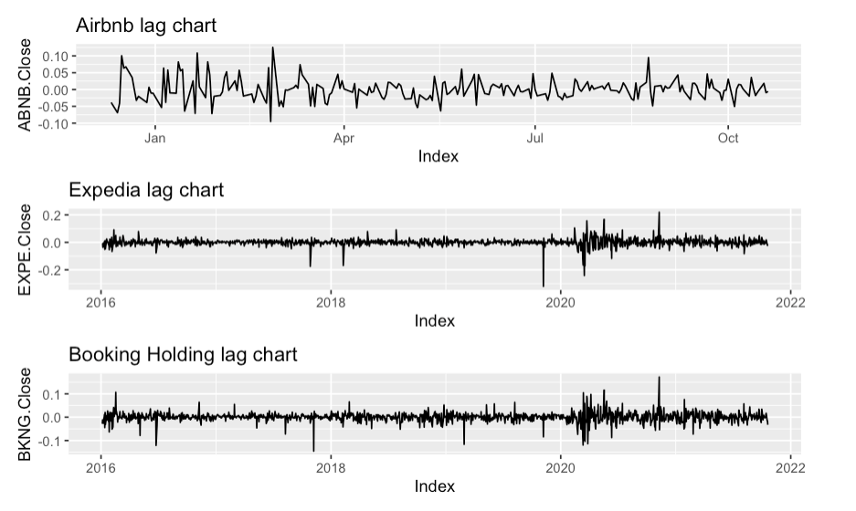

Now that we have performed the log transformations, we will verify stationarity using the Kwiatkowski-Phillips-Schmidt-Shin (KPSS) test to observe whether or not our time series data is truly stationary. The KPSS test is often referred to as a unit root test, and below are the results of Airbnb, Expedia, and Booking Holdings, in the respective order.

**Airbnb**

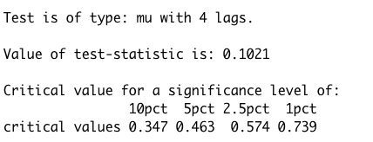

**Expedia**

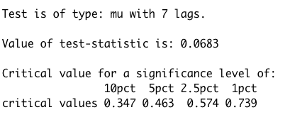

**Booking Holdings**

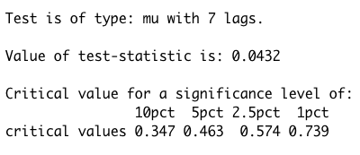

From our KPSS test, we can see that all three models are statistically significant at the 1, 2.5, 5, and 10 percent levels of significance. Demonstrating that after all these transformations our three models have been controlled for any trends and seasonality.

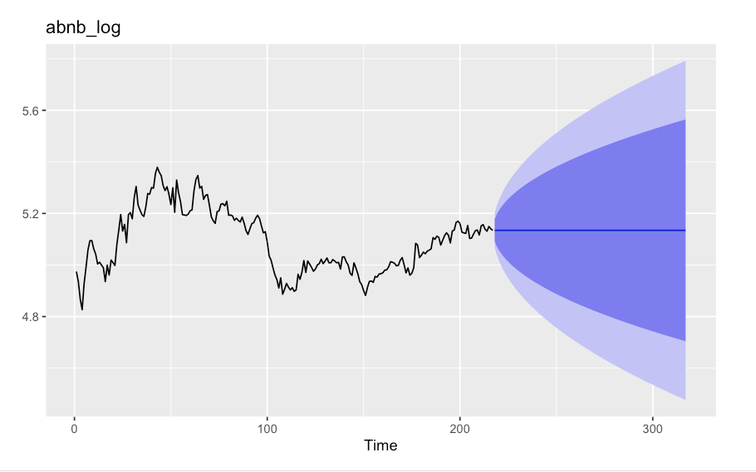

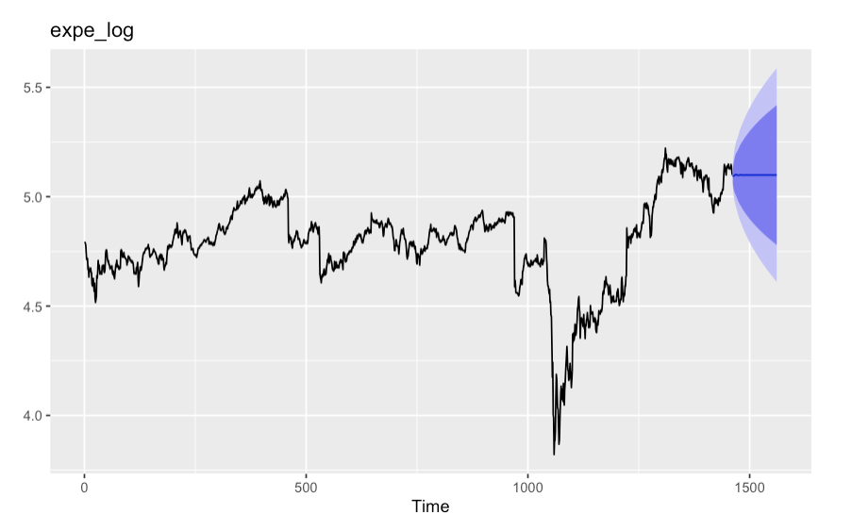

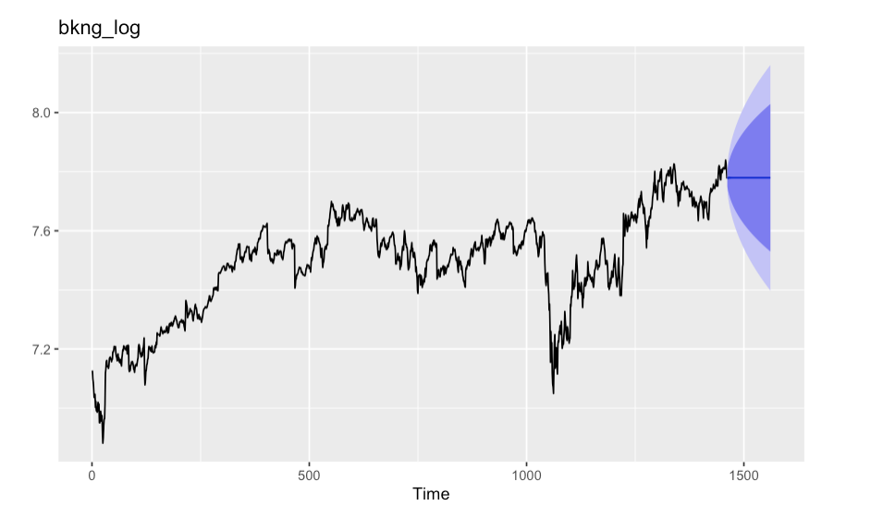

All our three models display mean reversion, in other words, we see a flat line indicating a static pattern across time. In our specific forecast we forecast out 100 periods, and in all the forecasts of Airbnb, Expedia, and Booking Holdings we can conclude that asset price volatility and historical returns will eventually revert to the long-run mean or average level of the entire dataset.

Something unique about our forecast model can be seen in our result for Airbnb. In our forecasted model, we can see large variability in pricing across time relative to Expedia and Booking Holdings. In the chart above the region highlighted in blue shows us the prediction interval. In the dark blue color, we see the 80% predictive interval, while in the lighter blue color we see the 95% predictive interval. In our model, we can see that Airbnb displays a higher likelihood of variability relative to Expedia and Booking Holdings. These results make sense because Airbnb is a newly established company since 2008 and naturally newer companies are more volatile in pricing. If we look at Expedia and Booking Holdings we see less variability in the 80% and 95% predictive intervals because although they are still subject to the same market pressures, expected returns in pricing per share are less volatile than a newer less established company like Airbnb.

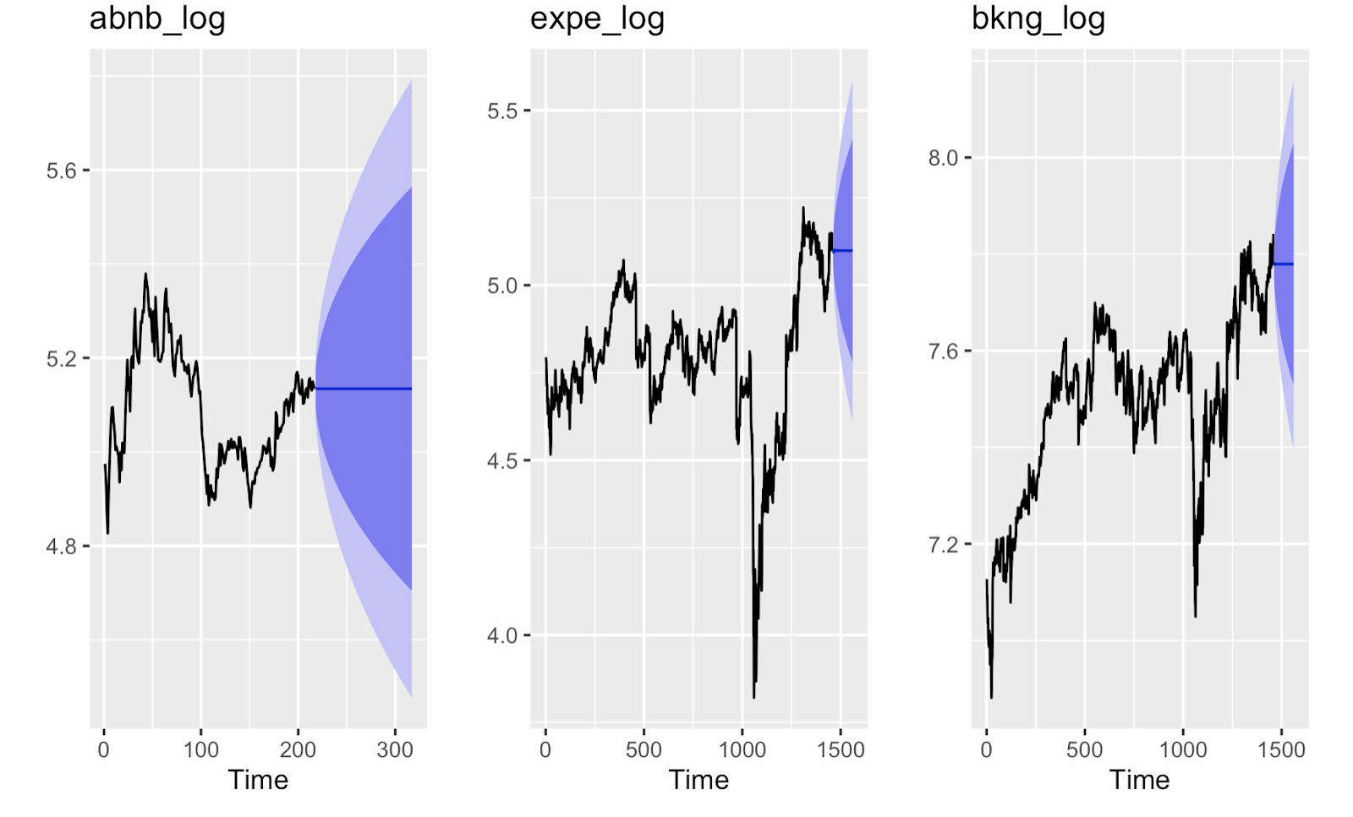

**ETS (error, trend, seasonality) Model:**

Our options for the ETS models are:

A - Additive

M - Multiplicative

N - None

Here are some of the models that we are going to try and measure with:

AAA - (additive trend, additive error, additive seasonality)

MAM - (multiplicative trend, additive error, multiplicative seasonality)

MAN - (multiplicative trend, additive error, no seasonality)

MAA - (multiplicative trend, additive error, additive seasonality)

MMM - (multiplicative trend, multiplicative error, multiplicative seasonality)

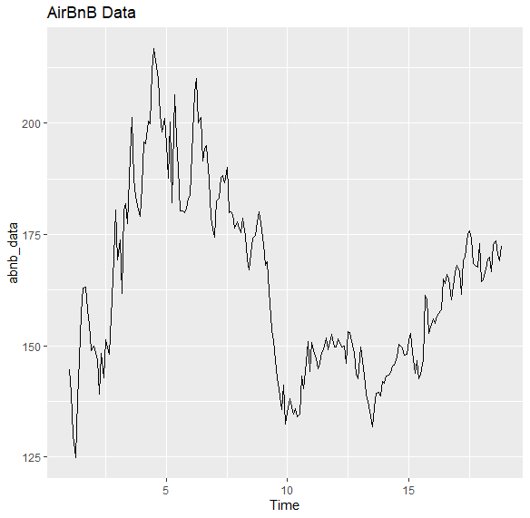 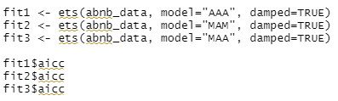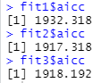

So here we see that fit 1 has the highest AICC, so that is what we are going to use.

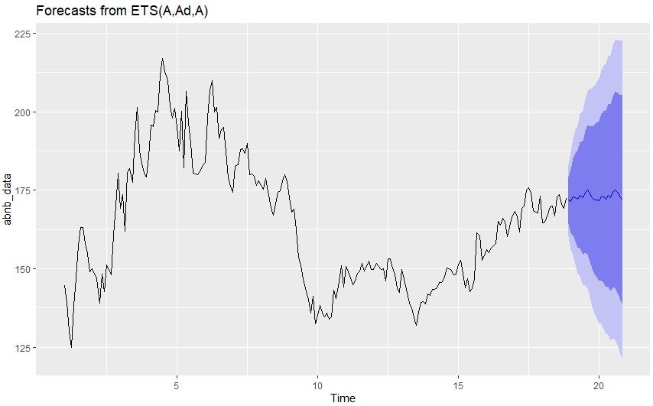

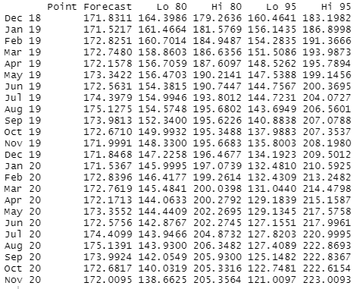

Then I ran the ets auto forecast and it gave me the MNN model:

abnb_data %>% ets() %>% forecast() %>% autoplot()

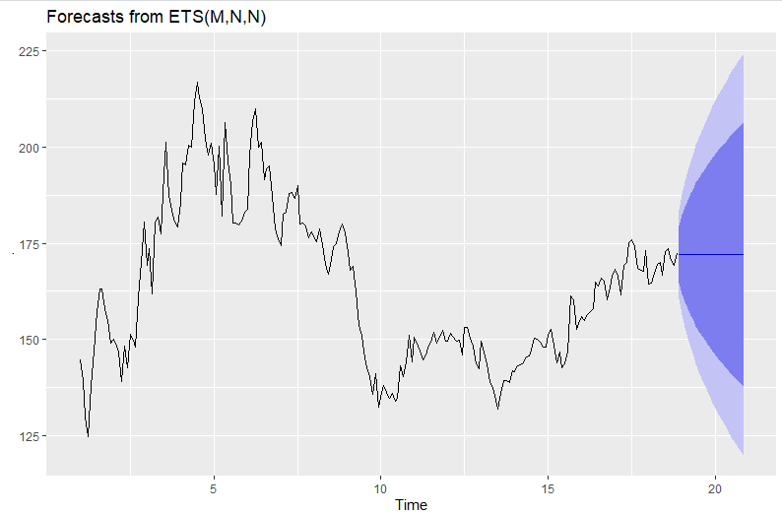

This forecast is static, suggesting that AirBnb’s forecast future stock prices will remain relatively the same as they are now. However we do see a large amount of variability in this data. This makes the stock look a lot more risky for investors.

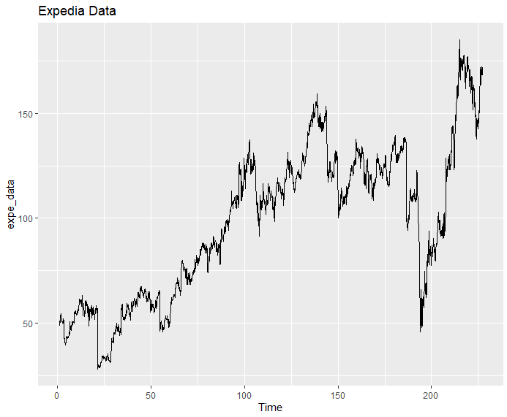

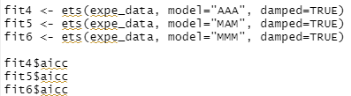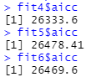

So here we see that fit 5 has the highest AICC, so that is what we are going to use.

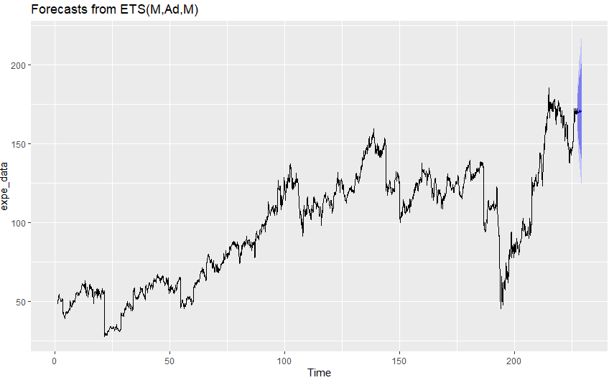

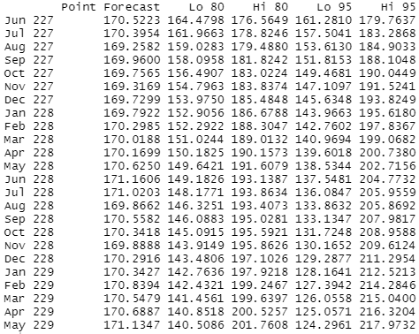

Then I ran the ets auto forecast and it gave me the ANN model:

expe_data %>% ets() %>% forecast() %>% autoplot()

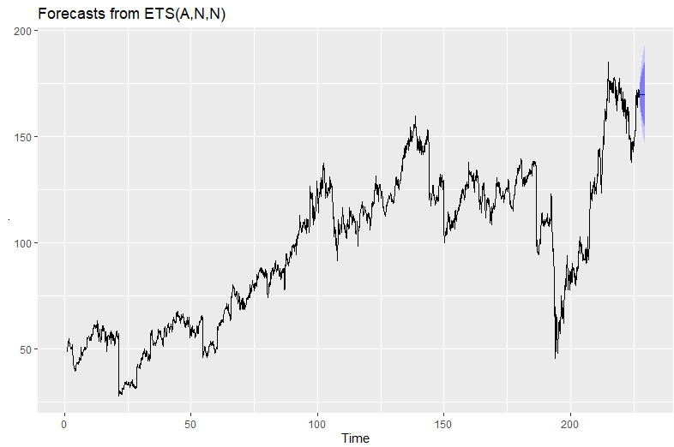

Again here this forecast is static, suggesting that Expedia’s forecast future stock prices will remain relatively the same as they are now. The variability is a lot less than it was for AirBnb, so this is a much less risky stock to invest in.

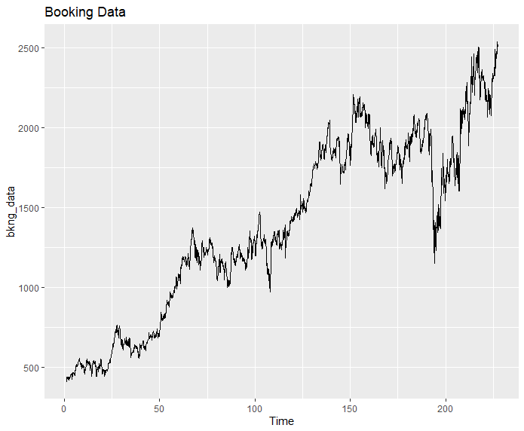

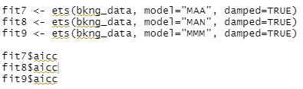 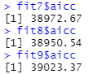

So here we see that fit 9 has the highest AICC, so that is what we are going to use.

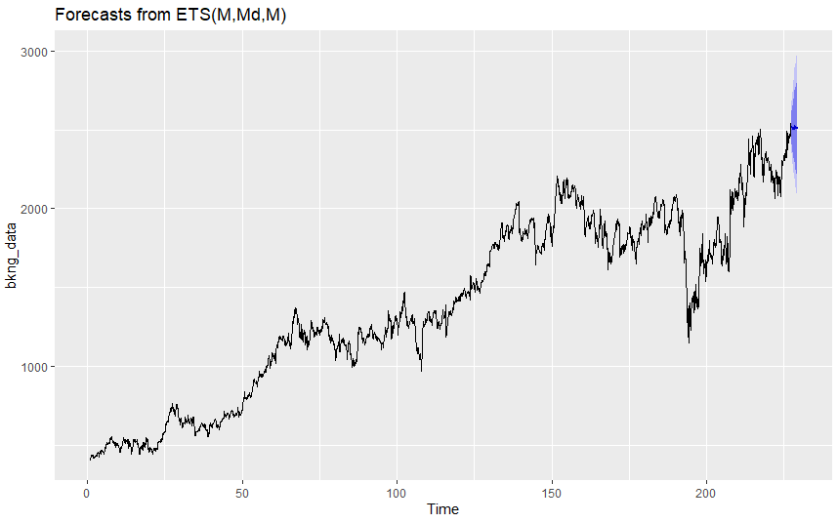

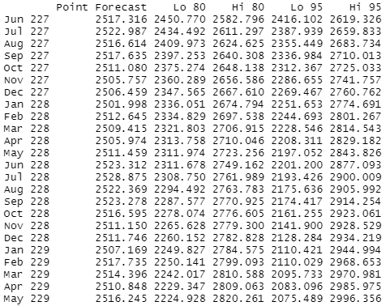

Then I ran the ets auto forecast and it gave me the MAN model:

bkng_data %>% ets() %>% forecast() %>% autoplot()

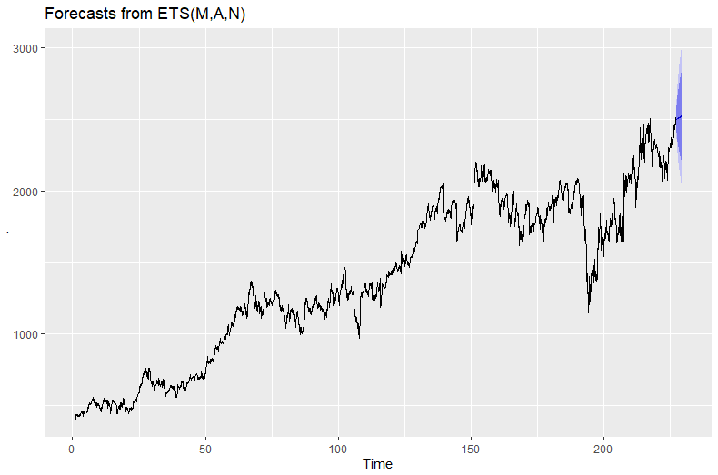

In this forecast we can see a slight upward trend in the stock price prediction.The variability seems to be about the same as Expedia, but the upward trend here is a much more promising sign.

**Facebook Prophet Model**

Facebook has recently developed the famous Prophet model that is publicly available for everyone to view. Here we use the Prophet model to capture daily, weekly and yearly seasonality along with holiday effects, by implementing [additive regression](https://en.wikipedia.org/wiki/Additive_model) models.

The mathematical equation behind the Prophet model is defined as:

y(t) = g(t) + s(t) + h(t) + e(t)

with, g(t) representing the trend. Prophet uses a piecewise linear model for trend forecasting.

s(t) represents periodic changes (weekly, monthly, yearly).

h(t) represents the effects of holidays (recall: Holidays impact businesses).

e(t) is the error term.

Here is what the forecast model and forecast values for the next 365 days look like for **Expedia**:

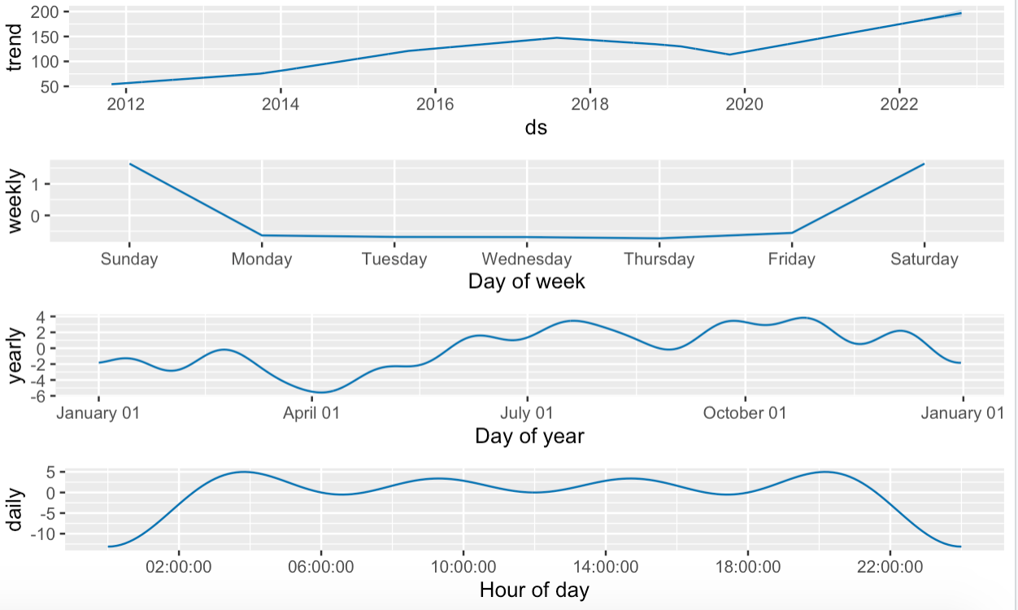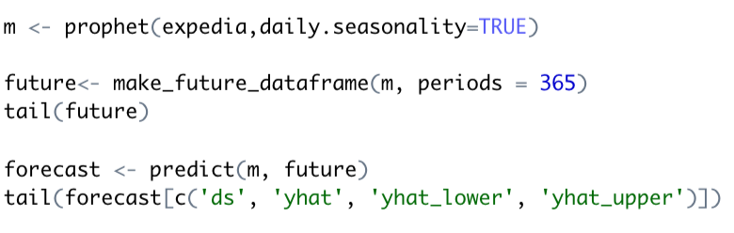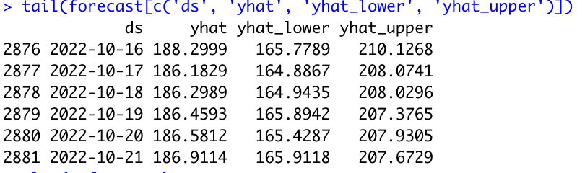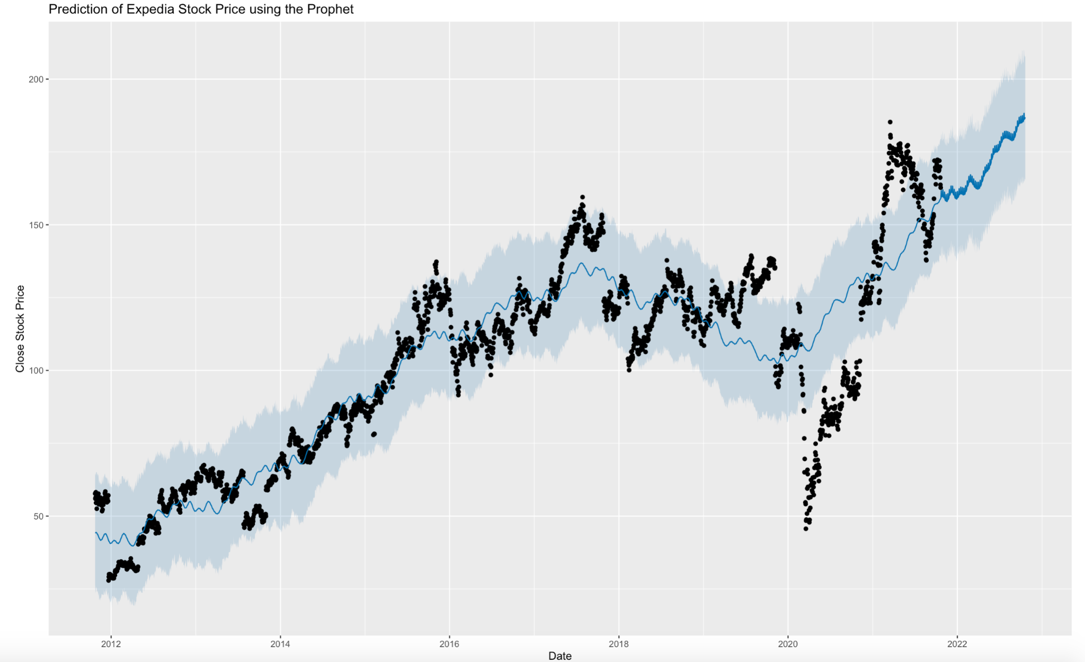

We can see that the Expedia stock exhibits an increasing trend overall with a dip in 2020 caused by the pandemic’s impact on tourism. If we look at the yearly seasonality pattern, the stock price exhibits a rise during the summer and winter months spurred by the holiday season. This is consistent with our expectations.

Here is what the forecast model and forecast values for the next 365 days look like for **Airbnb**:

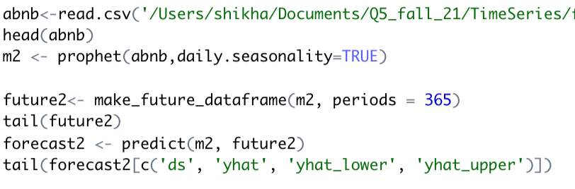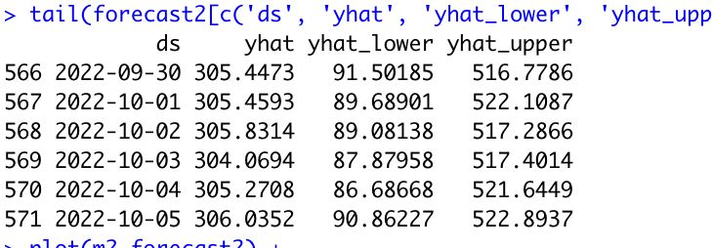

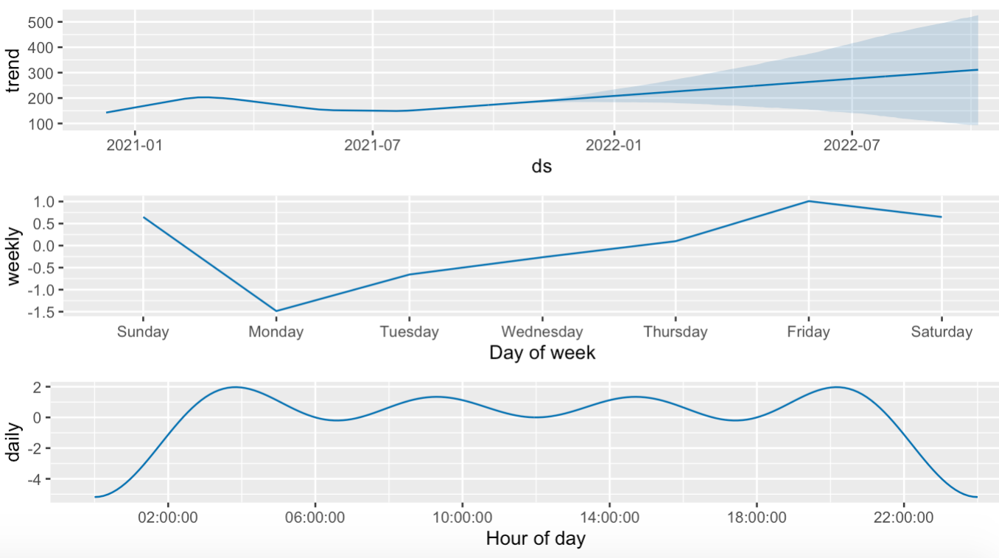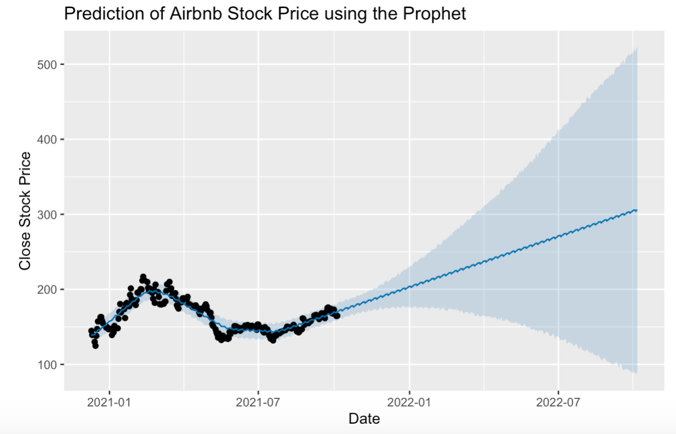

With the limited data we have for Airbnb, we can see that the Airbnb stock exhibits an overall marginally increasing trend. We also notice a strong weekly seasonality pattern where the stock price typically increases from the middle of the week to the end of the week. It is lowest on Mondays.

Here is what the forecast model and forecast values for the next 365 days look like for **Booking.com**:

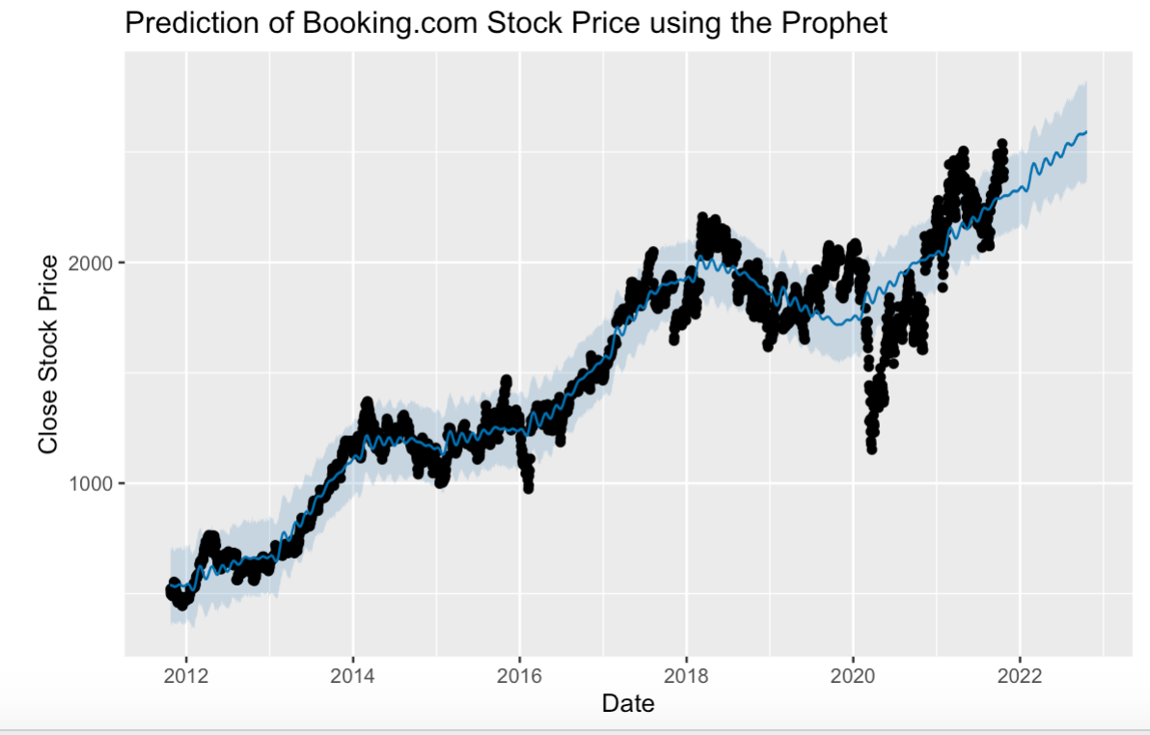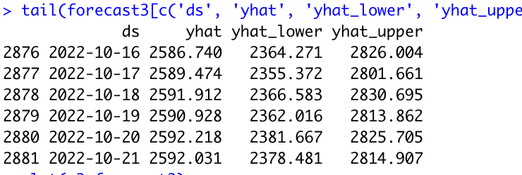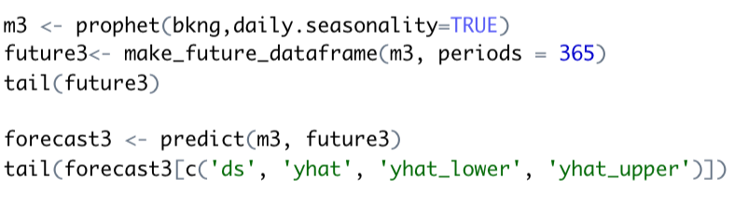

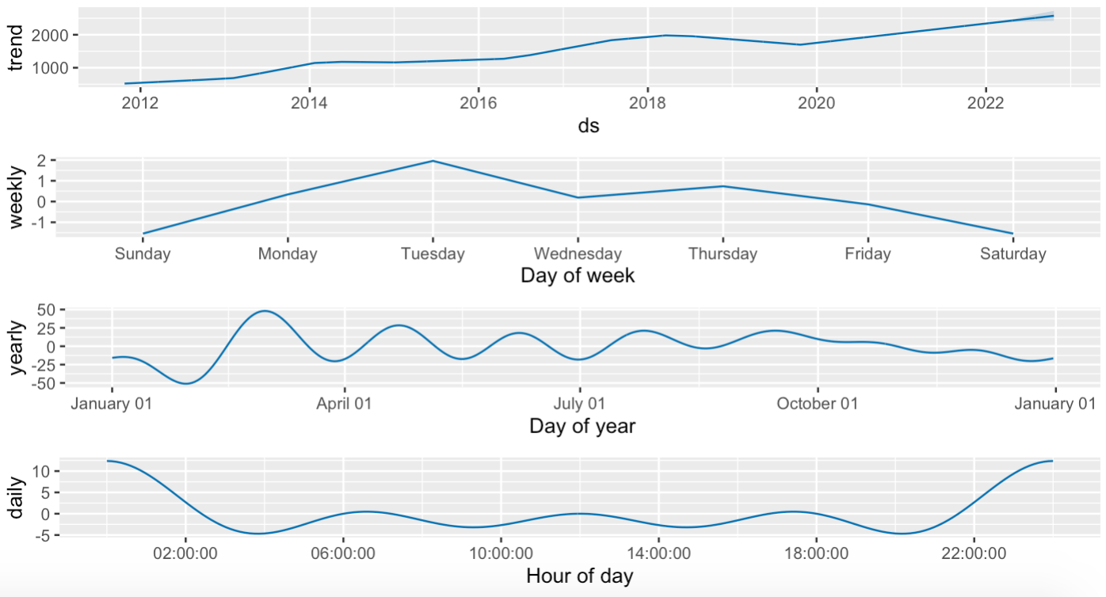

We can see that Booking.com stock exhibits an increasing trend with a sharp dip in 2020 caused by the pandemic’s impact on tourism. The stock price post 2020 has already surpassed the pre pandemic price levels. Here the stock price exhibits a strong weekly seasonality pattern with Tuesday being the day of the week when the maximum closing price is recorded.

Prophet includes functionality for time series cross validation to measure forecast error using historical data. This is done by selecting cutoff points in the history, and for each of them fitting the model using data only up to that cutoff point. We can then compare the forecasted values to the actual values.

Here we do cross-validation to assess prediction performance on a horizon of 365 days, starting with 1800 days of training data in the first cutoff and then making predictions every 180 days. On this 10 year time series, this corresponds to 9 forecasts with cutoffs between 2016-11-11 and 2020-10-21.

Cross validation performance metrics can be visualized with plot_cross_validation_metric, here shown for MAPE (mean absolute percentage error). Dots show the absolute percent error for each prediction in df_cv. The blue line shows the MAPE, where the mean is taken over a rolling window of the dots. We see for this forecast that for Expedia errors around 20% are typical for predictions one month into the future, and that errors increase up to around 40% for predictions that are a year out. For Airbnb, errors around 8% are typical for predictions 10 days into the future, and that errors increase up to around 18% for predictions that are forty days out. For Booking.com, errors around 10% are typical for predictions one month into the future, and that errors increase up to around 20% for predictions that are a year out.

**EXPEDIA AIRBNB BOOKING.COM**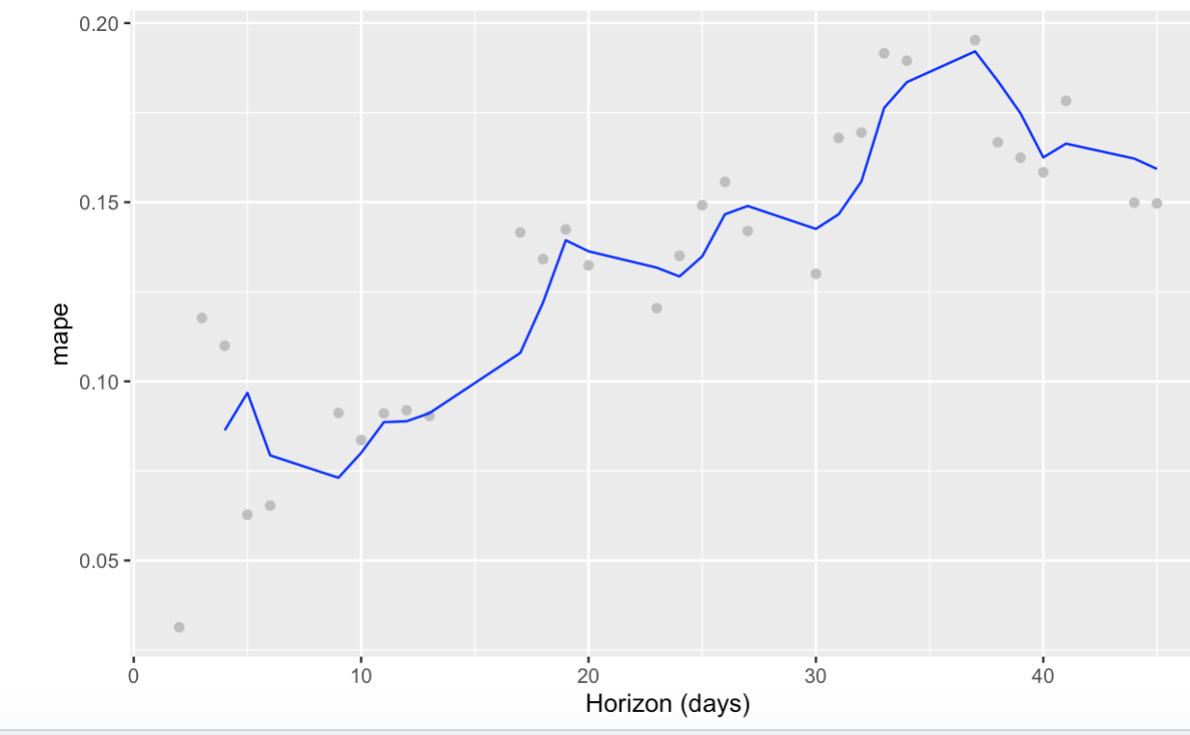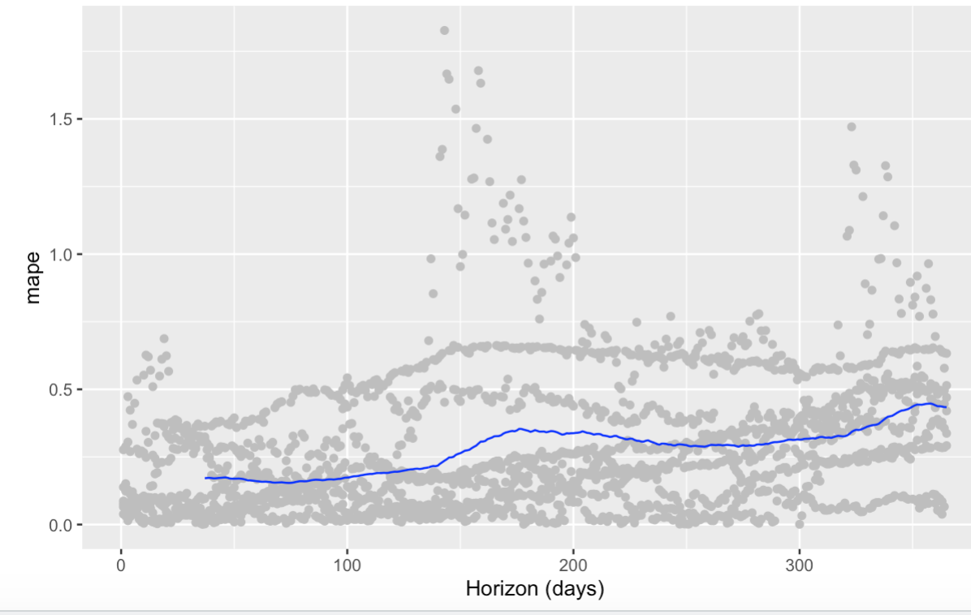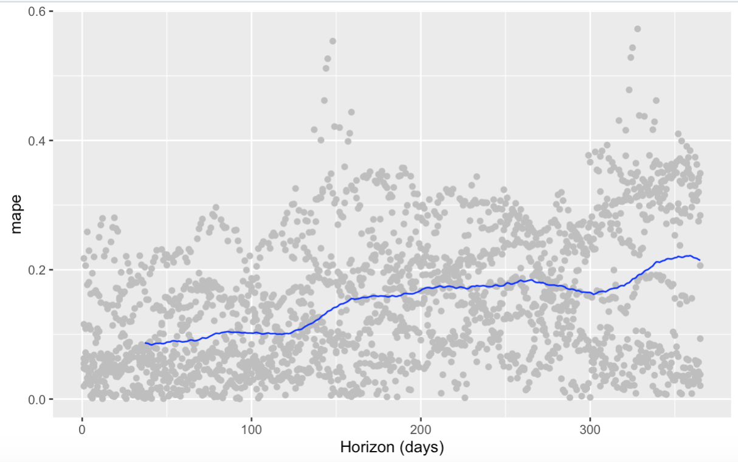

**Recommendation**

Overall, we would suggest two recommendations, for the investor who is risk-loving and looking to maximize portfolio value in the long run then Airbnb shows promising results as the greater variability in spread of the 95% predictive interval shows us that Airbnb may reach a higher stock price value across time. For the risk-averse investor, our recommendation would be to stick to a well-recognized company like Expedia and Booking Holdings as these two companies show less volatility in price, as we can see that the spread for both these companies in the ARIMA model and ETS model above shows a smaller magnitude in the 95% predictive interval.